# 

TASK-1

LOAD AND EXPLORE A DATASET

In this task , I have selected iris as dataset .

## DATA LOADING:

In this ,by using pandas library in python we can import dataset into our application.

### Code:

Import pandas as pd

# Load the Iris dataset

url = "https://archive.ics.uci.edu/ml/machine-learning-databases/iris/iris.data"

c = ["sl", "sw", "pl", "pw", "species"]

df = pd.read_csv(url, names=c)

# Display the first few rows of the dataset

print(df.head())

### RESULT:

sl sw pl pw species

0 5.1 3.5 1.4 0.2 Iris-setosa

1 4.9 3.0 1.4 0.2 Iris-setosa

2 4.7 3.2 1.3 0.2 Iris-setosa

3 4.6 3.1 1.5 0.2 Iris-setosa

4 5.0 3.6 1.4 0.2 Iris-setosa

## DATASET OVERVIEW:

Here we use mainly five features of iris dataset.

1.sl indicates sepal length(in cm)

2.sw indicates sepal width(in cm)

3.pl indicates petal length (in cm)

4.pw indicates petal width(in cm)

5.species ,it can consider as target variable with three main classes.they are setosa,virgnica,versicolor.

### SUMMARY STATISTICS:

Here we are calculating the statistics for numerical features.

### CODE:

ss = df.describe()

print(ss)

## RESULT:

sl sw pl pw

count 150.000000 150.000000 150.000000 150.000000

mean 5.843333 3.054000 3.758667 1.198667

std 0.828066 0.433594 1.764420 0.763161

min 4.300000 2.000000 1.000000 0.100000

25% 5.100000 2.800000 1.600000 0.300000

50% 5.800000 3.000000 4.350000 1.300000

75% 6.400000 3.300000 5.100000 1.800000

max 7.900000 4.400000 6.900000 2.500000

## DATA VISUALIZATION:

Here we are create some visualization for this data to better understand and analysis. In this we create pairplot relationship between pair of features and color coded by species.

## CODE:

import seaborn as sns

import matplotlib.pyplot as plt

# Pair plot

sns.pairplot(df, hue="species", markers=["o", "s", "D"])

plt.show()

## RESULT:

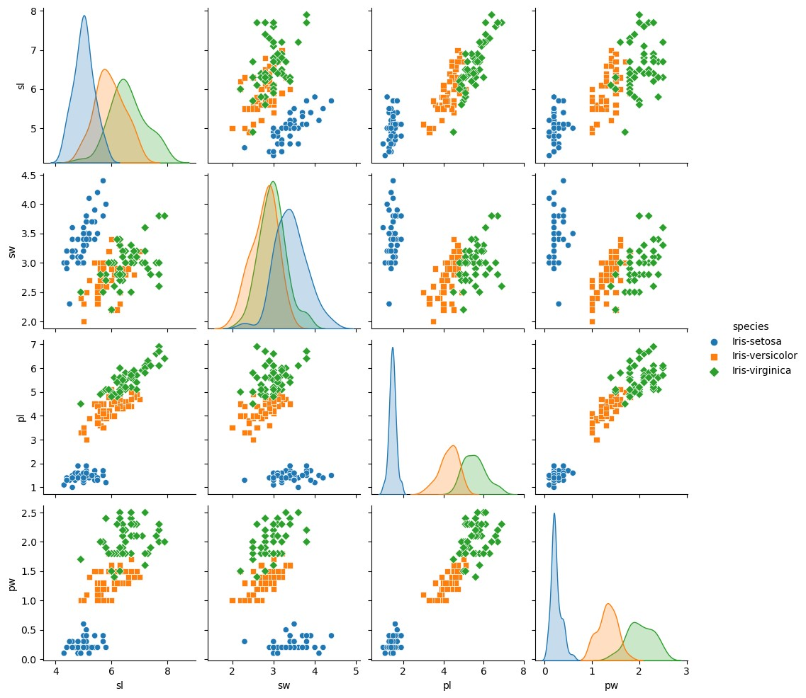

## RESOURCE:

1.Jupyter notebook

2.Dataset: https://archive.ics.uci.edu/ml/machine-learning-databases/iris/iris.data

3. Module: 1. pandas

2. seaborn

3.matplotlib

# 